**OWSAP**

**Penetration Testing Report**

1. **Introduction**

This report document hereby describes the proceedings and results of a Black Box security assessment conducted against for **Open Web Application Security Project (OWSAP).** The report hereby lists the findings and corresponding best practice mitigation actions and recommendations.

1. **Objective**

The objective of the assessment was to assess the state of security and uncover vulnerabilities in **Open Web Application Security Project(OWSAP)** and provide with a final security assessment report comprising vulnerabilities, remediation strategy and recommendation guidelines to help mitigate the identified vulnerabilities and risks during the activity.

1. **Scope**

This section defines the scope and boundaries of the project.

| **Application Name** | Open Web Application Security Project(OWSAP) |
| --- | --- |
| **URL** |  |

## Assessment Attribute(s)

| **Parameter** | **Value** |
| --- | --- |
| Starting Vector | External |
| Target Criticality | Critical |
| Assessment Nature | Cautious & Calculated |
| Assessment Conspicuity | Clear |
| Proof of Concept(s) | Attached wherever possible and applicable. |

## Risk Calculation and Classification

Following is the risk classification:

| **Info** | **Low** | **Medium** | **High** | **Critical** |
| --- | --- | --- | --- | --- |
| No direct threat to host/ individual user accounts. Sensitive information can be revealed to the adversary. | Vulnerabilities may not have public exploit (code) available or cannot be exploited in the wild. Vulnerability observed may not have a high rate of occurrence. Patch workaround released by vendor. | Vulnerabilities may not have public exploit (code) available or cannot be exploited in the wild. Patch/ workaround not yet released by vendor. | Vulnerabilities which can be exploited publicly, workaround or fix/ patch available by vendor. | Vulnerabilities which can be exploited publicly, workaround or fix/ patch may not be available by vendor. |

Table 1: Risk Rating

**Summary**

Outlined is a Black Box Application Security assessment for **DVWA**.

| [**http://127.0.0.1/DVWA/vulnerabilities/exec/**](http://127.0.0.1/DVWA/vulnerabilities/exec/) |
| --- |
| [**http://127.0.0.1/DVWA/vulnerabilities/sqli/**](http://127.0.0.1/DVWA/vulnerabilities/sqli/) |

Following section illustrates **Detailed** Technical information about identified vulnerabilities.

**Total: 3 Vulnerabilities**

| **High** | **Medium** | **Low** |
| --- | --- | --- |
| **1** | **1** | **2** |

# 1.1 Interesting files found

| **Reference No:** | **Risk Rating:** |
| --- | --- |
| files_01 | **Low** |
| **Tools Used:** | |
| Browser | |
| **Vulnerability Description:** | |
| These files/folders usually contain sensitive information which may help attackers to mount further attacks against the server. Manual validation is required | |
| **Vulnerability Identified by / How It Was Discovered** | |
| Manual Analysis | |
| **Vulnerable URLs / IP Address** | |
| <http://127.0.0.1/DVWA/.gitignore> | |
| **Implications / Consequences of not Fixing the Issue** | |
| Attackers will often attempt to exploit unpatched flaws or access default accounts, unused pages, unprotected files and directories, etc to gain unauthorized access or knowledge of the system. | |
| **Suggested Countermeasures** | |
| * We recommend you to analyze if the mentioned files/folders contain any sensitive information. * Restrict their access according to the business purposes of the application. | |
| **References** | |
| [A6:2017-Security Misconfiguration | OWASP](https://owasp.org/www-project-top-ten/2017/A6_2017-Security_Misconfiguration.html) | |

**Proof of concept:**

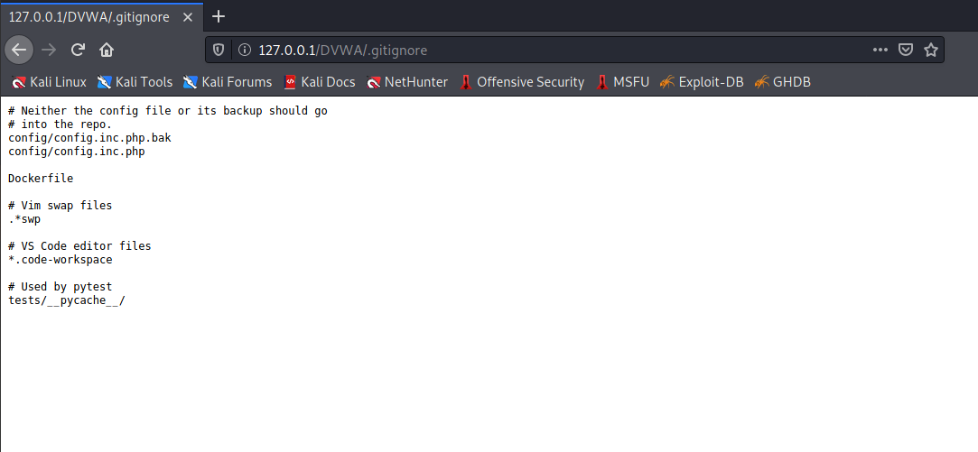

**Fig 1:gitignore file found. It is possible to grasp the directory structure**

**1.2 Interesting files found**

| **Reference No:** | **Risk Rating:** |
| --- | --- |
| Config_02 | **Low** |
| **Tools Used:** | |
| Browser | |
| **Vulnerability Description:** | |
| Security misconfiguration can happen at any level of an application stack, including the network services, platform, web server, application server, database, frameworks, custom code, and pre-installed virtual machines, containers, or storage. Automated scanners are useful for detecting misconfigurations, use of default accounts or configurations, unnecessary services, legacy options, etc. | |
| **Vulnerability Identified by / How It Was Discovered** | |
| Manual Analysis | |
| **Vulnerable URLs / IP Address** | |
| <http://127.0.0.1/DVWA/config/> | |
| **Implications / Consequences of not Fixing the Issue** | |
| Such flaws frequently give attackers unauthorized access to some system data or functionality. Occasionally, such flaws result in a complete system compromise.  The business impact depends on the protection needs of the application and data | |
| **Suggested Countermeasures** | |
| It is recommended to secure installation processes should be implemented, including :   * A repeatable hardening process that makes it fast and easy to deploy another environment that is properly locked down. Development, QA, and production environments should all be configured identically, with different credentials used in each environment. This process should be automated to minimize the effort required to set up a new secure environment. * A minimal platform without any unnecessary features, components, documentation, and samples. Remove or do not install unused features and frameworks. | |
| **References** | |
| [A6:2017-Security Misconfiguration | OWASP](https://owasp.org/www-project-top-ten/2017/A6_2017-Security_Misconfiguration) | |

**Proof of concept:**

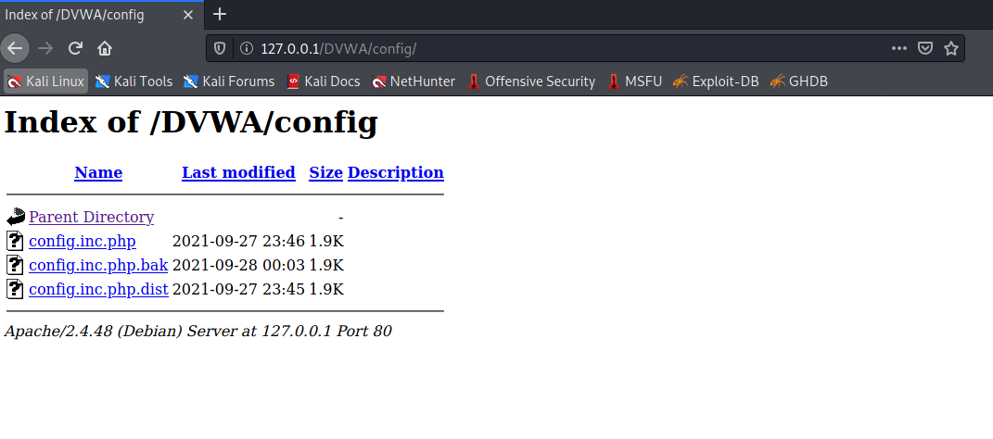

**Fig 1: Directory indexing found.**

# Insufficient Password Policy .

| **Reference No:** | **Risk Rating:** |
| --- | --- |
| Insufficient_Password_Policy_01 | **Medium** |
| **Tools Used:** | |
| Browser | |
| **Vulnerability Description:** | |
| * Users of the application can set a weak password. These passwords are prone to brute-force attacks. * The confidentiality cannot be ensured. | |
| **Vulnerability Identified by / How It Was Discovered** | |
| Manually | |
| **Vulnerable URLs / IP Address** | |
| <http://127.0.0.1/DVWA/vulnerabilities/brute/> | |
| **Implications / Consequences of not Fixing the Issue** | |
| An attacker could easily guess user passwords and gain access to user accounts. | |
| **Suggested Countermeasures** | |
| * Enforcement of a minimum and maximum length * Restrictions against password reuse * Restrictions against using common passwords * Restrictions against using contextual string in the password (e.g., user id, app name) | |
| **References** | |
| [CWE - CWE-521: Weak Password Requirements (4.5)](https://cwe.mitre.org/data/definitions/521.html) | |

**Proof of concept:**

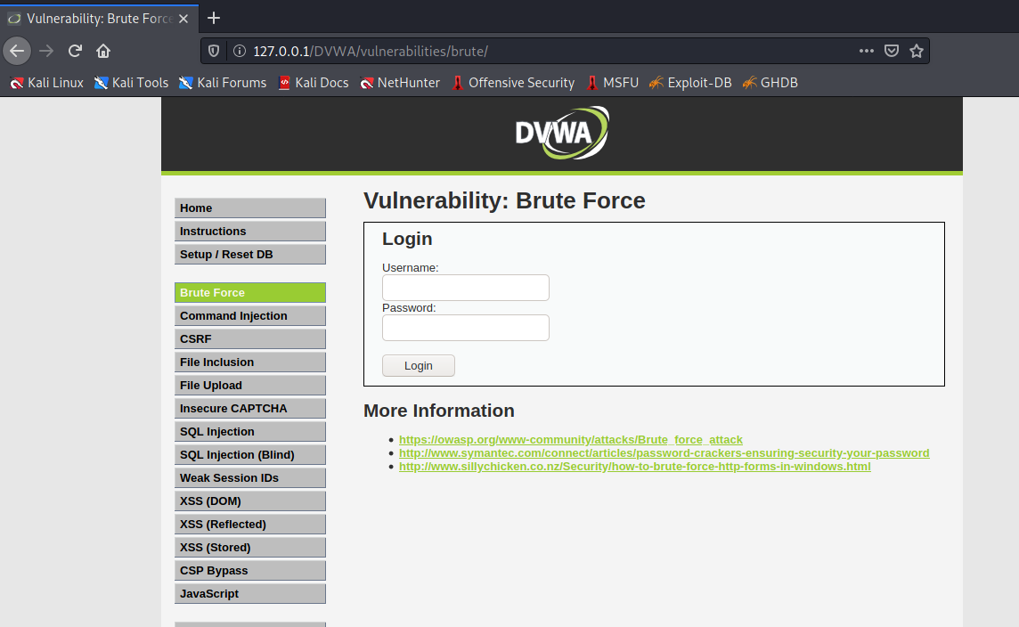

**Fig 1: Weak Password Requirements**

# 3.SQL Injection

| **Reference No:** | **Risk Rating:** |
| --- | --- |
| SQL_Injection_01 | **High** |
| **Tools Used:** | |
| Browser | |
| **Vulnerability Description:** | |
| The web application is prone to SQL injections. In consequence, all data of the database can be  potentially accessed or manipulated by an attacker. | |
| **Vulnerability Identified by / How It Was Discovered** | |
| Manual Analysis | |
| **Vulnerable URLs / IP Address** | |
| <http://127.0.0.1/DVWA/vulnerabilities/sqli/> | |
| **Implications / Consequences of not Fixing the Issue** | |
| The risk exists that an attacker gains unauthorized access to the information from the database of the application. He could extract information such as: application usernames, passwords, client information and other application specific data. | |
| **Suggested Countermeasures** | |
| * We recommend implementing a validation mechanism for all the data received from the users. * The best way to protect against SQL Injection is to use prepared statements for every SQL query performed on the database. * Otherwise, the user input can also be sanitized using dedicated methods such as: mysqli_real_escape_string. | |
| **References** | |
| * [SQL Injection | OWASP](https://owasp.org/www-community/attacks/SQL_Injection) * [CheatSheetSeries/SQL_Injection_Prevention_Cheat_Sheet.md at master · OWASP/CheatSheetSeries](https://github.com/OWASP/CheatSheetSeries/blob/master/cheatsheets/SQL_Injection_Prevention_Cheat_Sheet.md) | |

**Proof of concept**

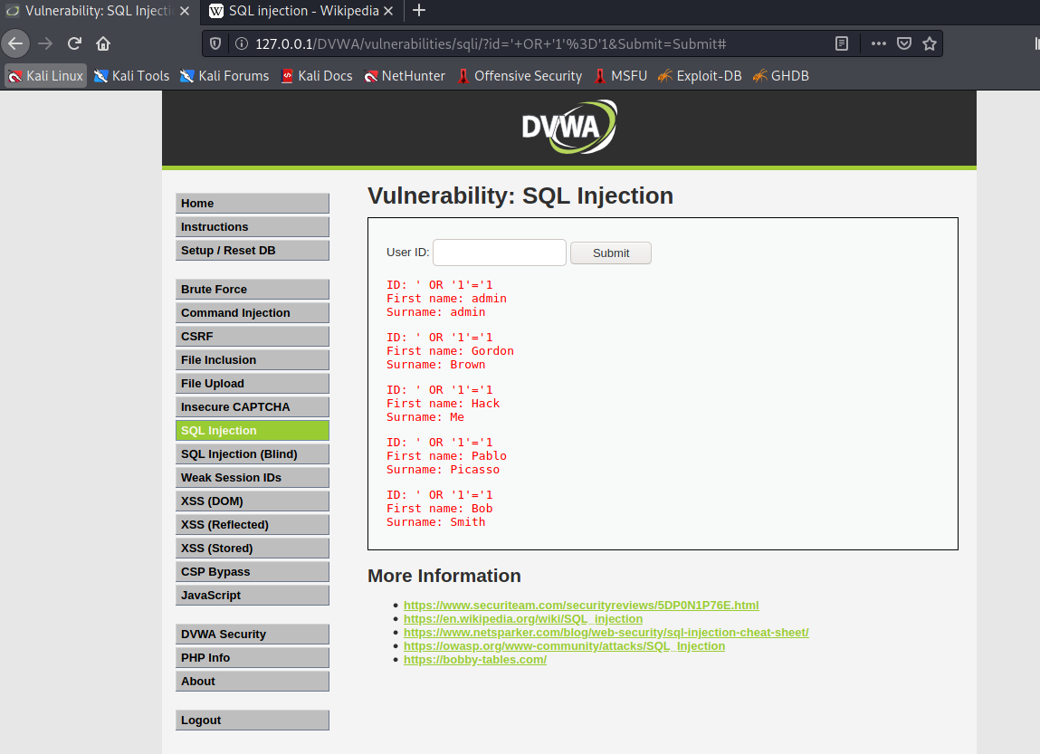

**Fig 1: SQL Injection**

---------------------------------------EOF-------------------------------------